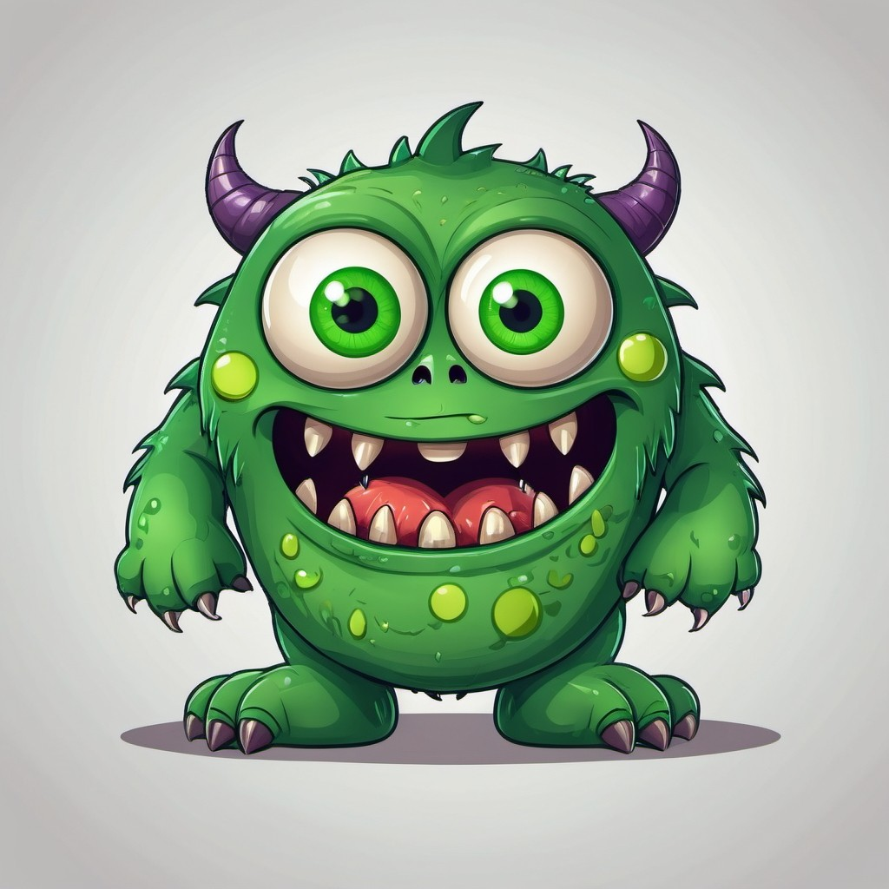
dangerous
bad
scary
animal
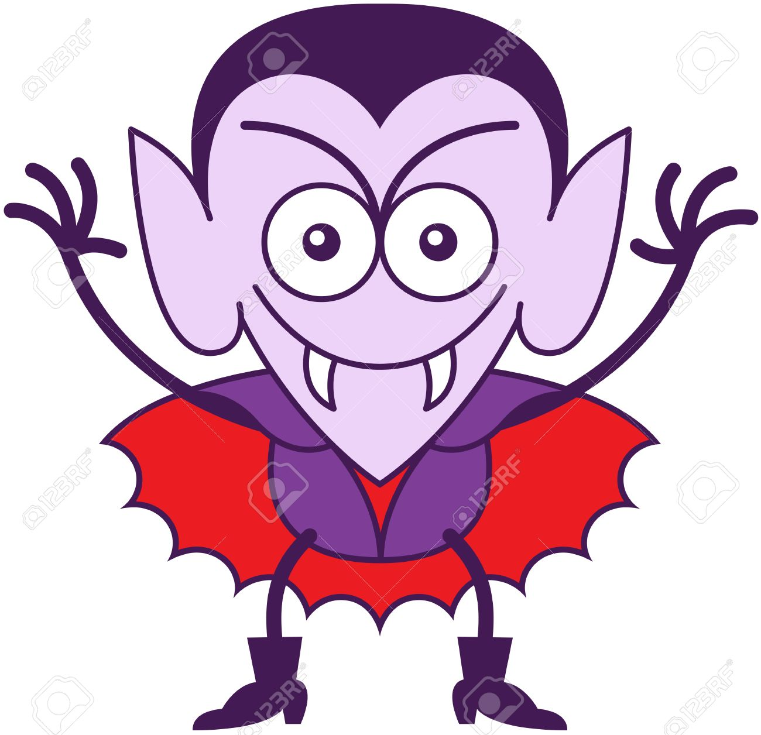
blood
teeth
bat
night

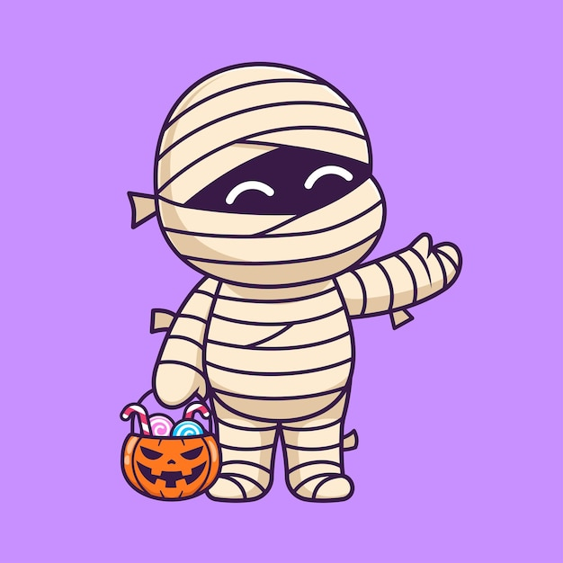
dead

bandages

Egypt

Human

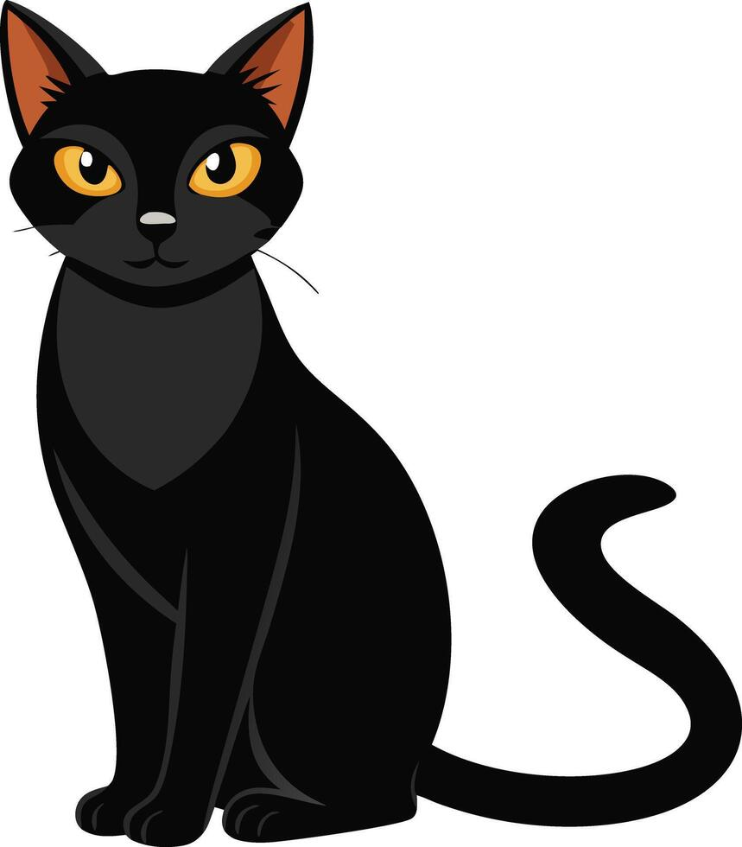
animal

pet

Bad luck

walk

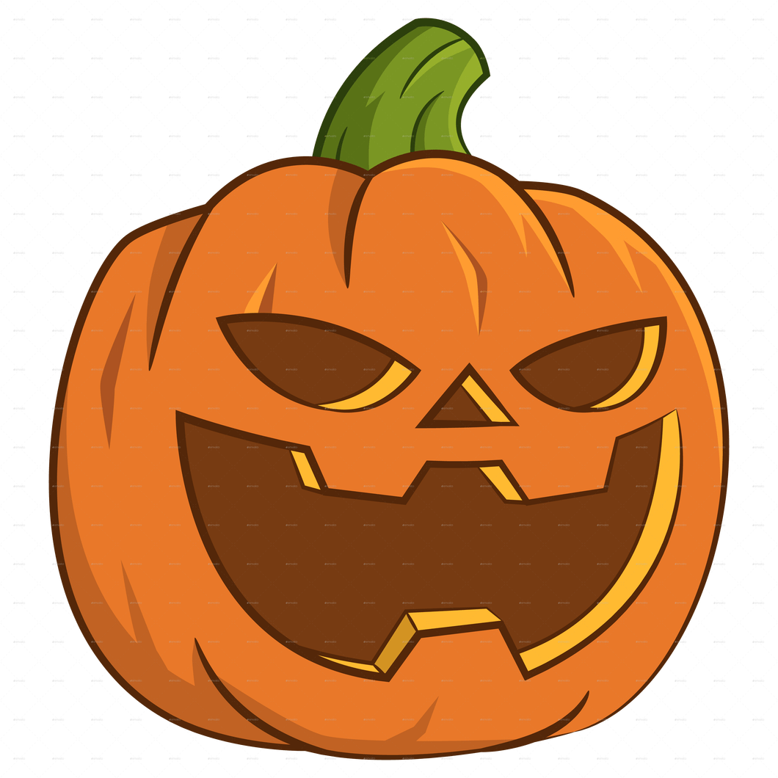
food

vegetable

lantern

orange

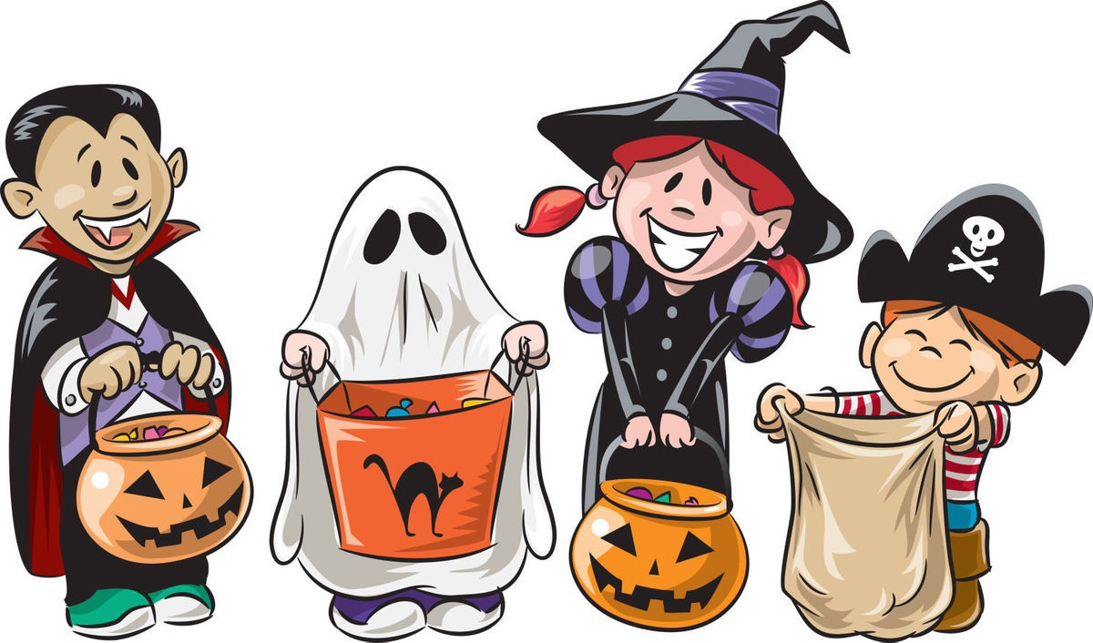
Children

Candy

House

knock

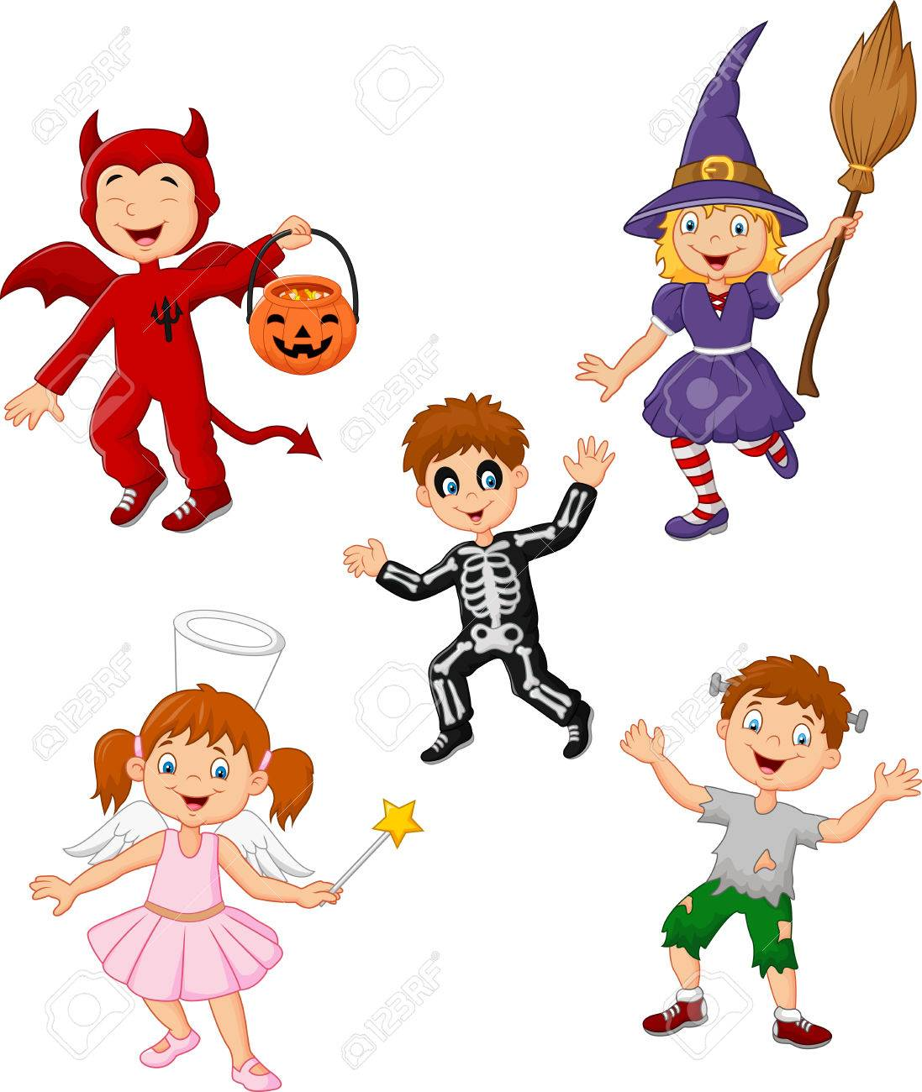
Clothes

Look

Wear

Party

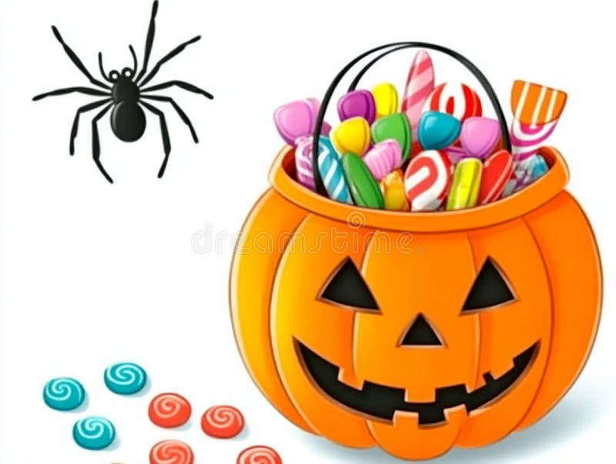
Sweet

Delicious

Sugar

Treat

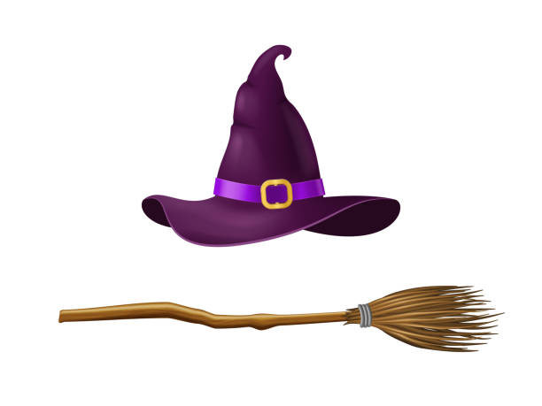
sweep

witch

Clean

Brush

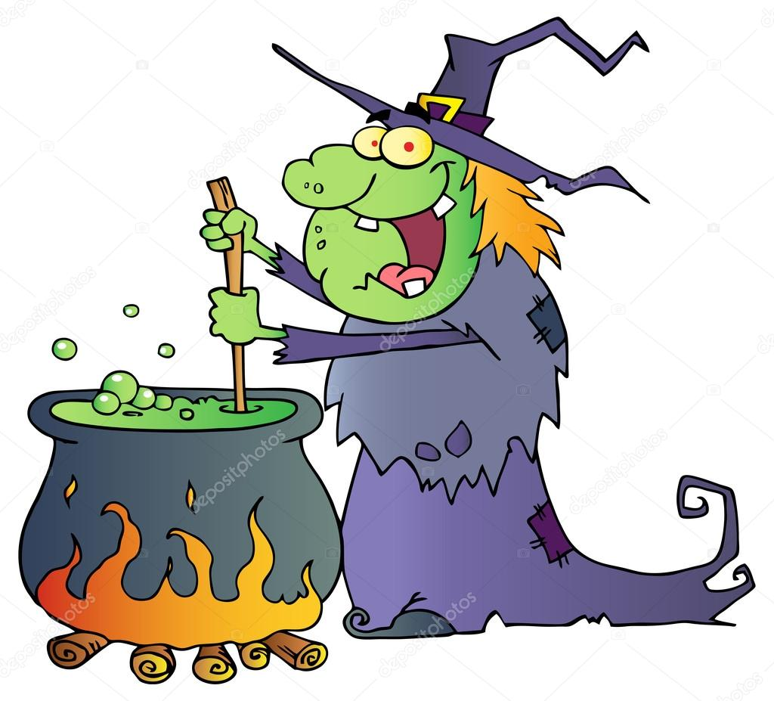
Brush

Brush

Brush

Brush

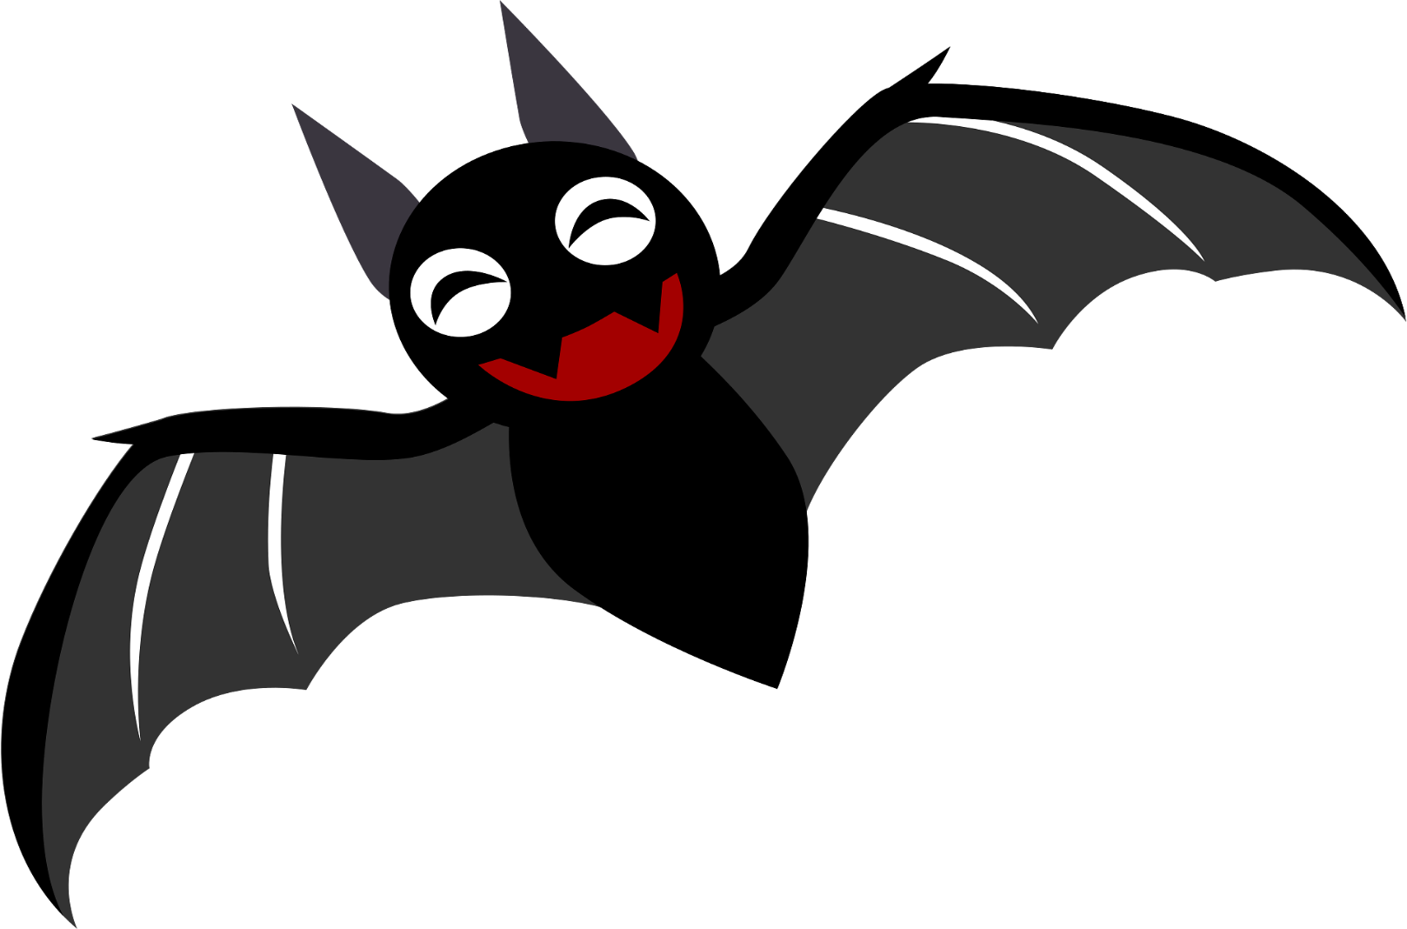
Animal

Fly

Blind

Vampire

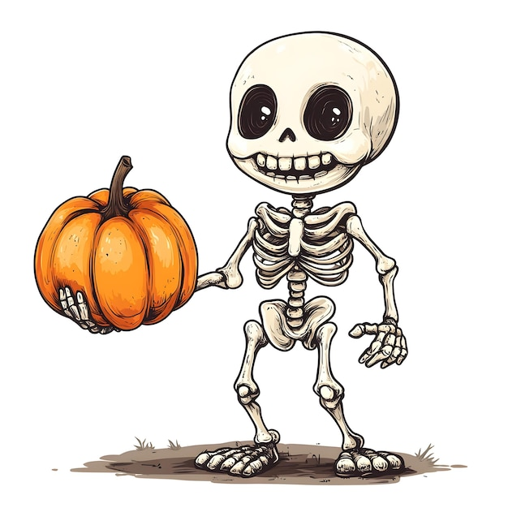
Dead

bones

Body

White

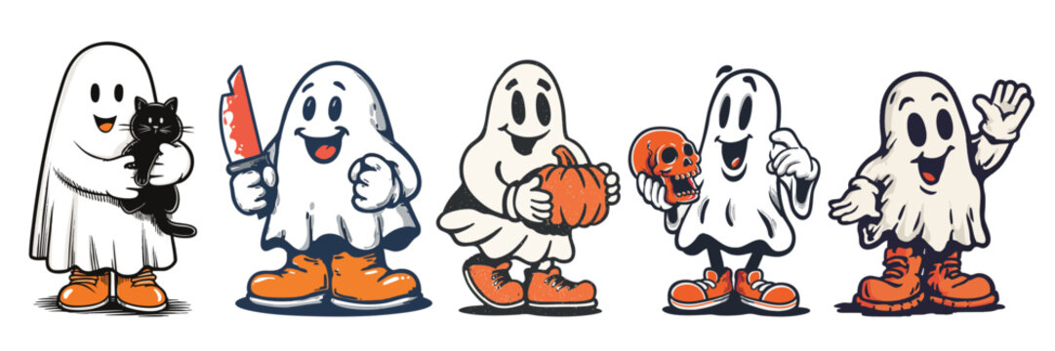
Dead

Scary

Haunted

Night

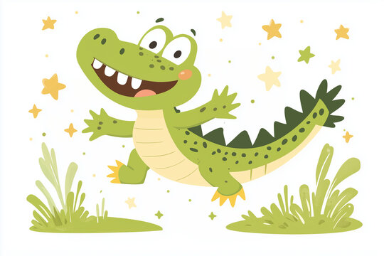
Dangerous

Long

River

Mouth

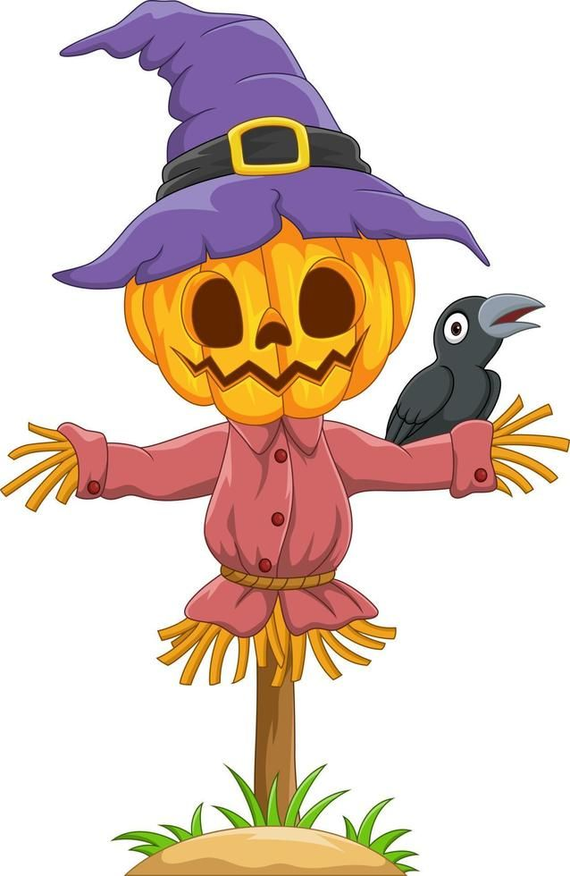
farm

Bird

straw

silent

